Will Cash Disappear?
摘自紐約時報https://cn.nytstyle.com/international/20171115/cashless-economy
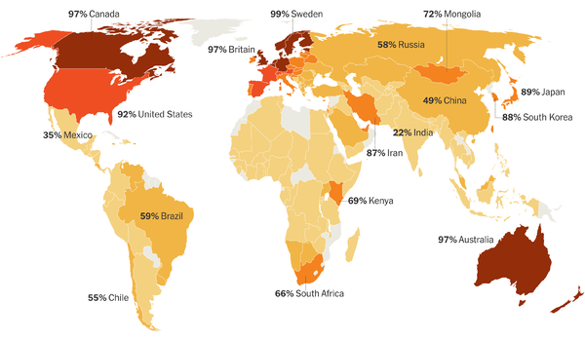Share of adults who made or received any noncash payment.各國成年人進行或接收無現金交易的比例。
- Cash is unlikely to go away soon. Coins and paper currency remain the most popular ways to pay for things in most countries. But longer term, cash appears to be in a losing battle with electronic payment methods.  2. But the movement away from cash is happening in very different ways and at varying paces around the world.  Scandinavian countries are already well along the road toward cashless societies. Many banks in Sweden no longer have cash on hand, and consumers can make instant transfers directly from their bank accounts.  In Kenya, the local mobile phone company Safaricom, not the banks or the government, has pushed the envelope. Safaricom created a system, known as M-Pesa, that allows customers to make payments directly from their phones.  3.China is the most talked-about location in the battle between cash and electronic payments. PayPal-like wallets created by Chinese online giants Alibaba and Tencent have become the most popular ways to pay for things online.  4. The benefits of moving away from cash have been trumpeted by economists like Kenneth Rogoff, who wrote “The Curse of Cash,” about how paper money enables crime and tax evasion.  But the critics of cash have been met by their own critics, who argue that electronic payments can disenfranchise poor people who lack easy access to bank accounts and the internet and can make it much easier for governments and corporations to monitor a person’s every step. | 1.現金不太可能太早被淘汰。硬幣和紙鈔仍是大多數國家最受歡迎的購物支付方式。但長期來說，現金在與電子支付方式的對抗中似乎處於下風。  - 在全球各地，這場擺脫現金的運動發生的方式和速度卻不盡相同。  斯堪地那維亞國家已經穩步邁向無現金社會。瑞典的許多銀行不再擁有現金，消費者可以直接從銀行帳戶進行即時轉賬。  在肯亞，推動革新的並非銀行或政府，而是當地的流動電話公司Safaricom。Safaricom創造了一個名為M-PESA的系統，讓消費者能直接從他們的手機付款。  3.在這場現金與電子支付間的對抗中，中國是人們談論得最多的國家。由中國在線巨人阿里巴巴和騰訊創造出的類似PayPal的手機錢包，已經成為網路購物最受歡迎的付款方式。  4. 經濟學家一直在鼓吹擺脫現金的好處。羅格夫著有《現金的詛咒》(The Curse Of Cash)，內容是有關紙幣如何使犯罪和逃稅成為可能。  但是批評現金的人自身也面臨批評者，後者認為電子支付會剝奪不易獲得銀行帳戶及使用互聯網的窮人的權利，並且可以使政府和企業更容易監控人的一舉一動。

Activity:
- Key words for each paragraph. Draw a mind map.
Discussions:
- Do you use any online/third-party payment?
- When do you think the cash will disappear?

